GDipICL Grade Review & Appeal Process
Effective 29 September 2026

Read First:
Section 6: The Handbook of Academic Regulations, Policies and Procedures
Checklist for Students - Grade Review and Appeal Process

Timeline Summary:
Stage | Deadline
- Student submits Formal Request for Grade Review to onQ course drop box. | Within 14 calendar days of grade release on SOLUS.
- Instructor renders decision on Formal Request for Grade Review via Feedback box in onQ. | Within 14 calendar days of receiving the request.
- Student submits Grade Appeal via onQ course drop box (if dissatisfied with Grade Review) | Within 14 calendar days of the Instructor’s decision.
- Coordinating Instructor / Academic Director adjudicates decision via Feedback box in onQ. | Within 14 calendar days of receiving the appeal.

Instructions – How to File a Formal Request for Grade Review Grade Appeal

- Formal Request for Grade Review

Students have 14 calendar days to submit a Formal Request for Grade Review to their Instructor after grades are posted on SOLUS. Instructors will provide a written decision to their student within 14 calendar days after the student’s Formal Request for Grade Review is received.

To Submit a Formal Request for Grade Review

- Enter your course in onQ

- Click Assessments > Assignments

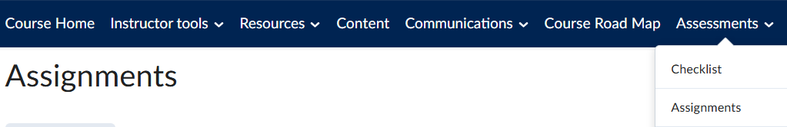

- Click Grade Review & Appeal

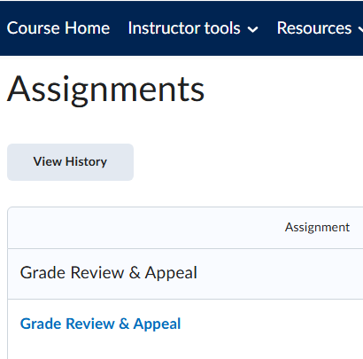

- Read the Grade Review and Appeal Checklist for Students prior to submitting.

Submitting a Formal Request for Grade Review File

- In the Comments box, attach your completed Formal Request for Grade Review form + submission to your Instructor.

- Click Add a File to attach your supporting documentation.

- Click Submit.

- If you obtain further supporting documentation within the 14-calendar day period, follow steps 5-7 to add this to your submission.

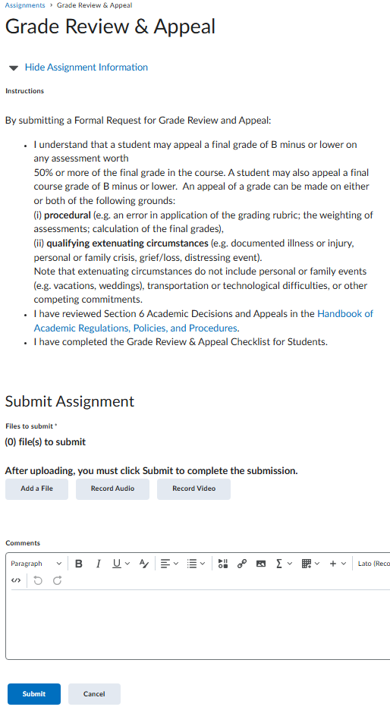
File Submission Receipt

- Depending on your onQ notification settings, you may receive an email confirming that your Formal Request for a Grade Review file has been submitted.

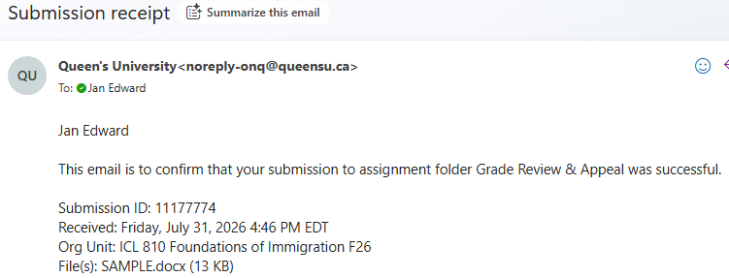

Verify File Submission Status

- Enter your course in onQ.
- Click Assessments > Assignments
- Beside Grade Review & Appeal under Completion Status, you will see “1 Submission, 1 File.”
  - If you made multiple submissions (ie. Submitted more than one letter or supporting documentation, then you would see that reflected here).

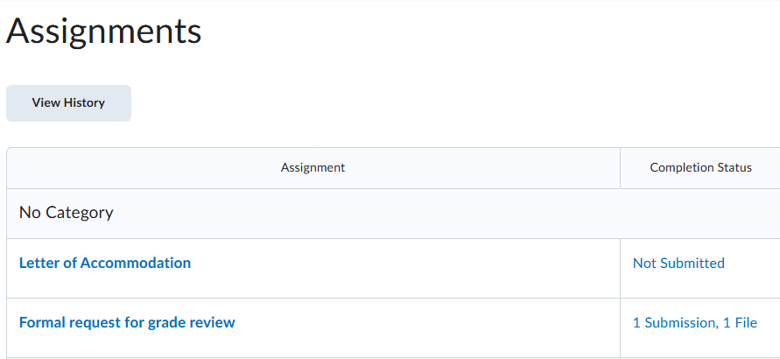
Grade Review & Appeal

Read Instructor Decision

- Enter your course in onQ.
- Click Assessments > Assignments
- After 14 calendar days from the time you submitted your Formal Request for Grade Review to your Instructor, if your Instructor has rendered their decision, beside Grade Review & Appeal you will see Feedback: Unread under Evaluation Status.
- Click Unread.

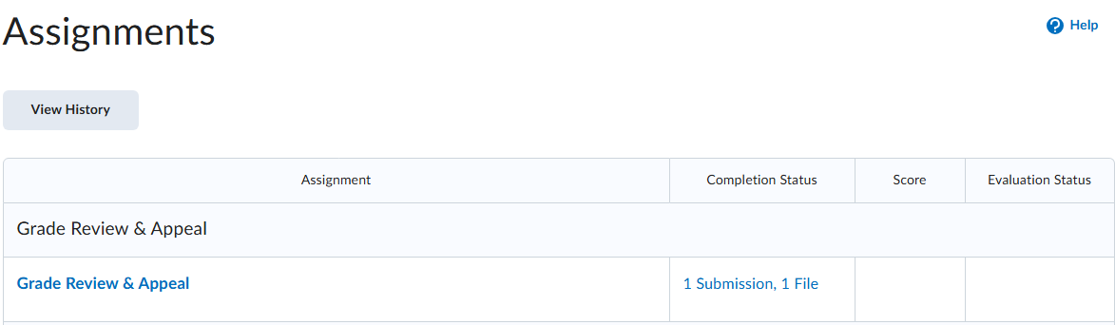
Feedback: Unread

- The Instructor’s decision may be written directly in the comments box or provided as an attachment.

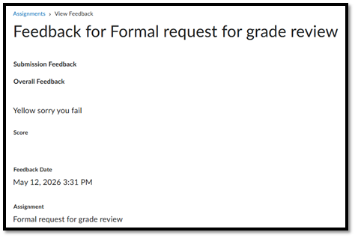
Please see the attachment.

Next Steps

If you accept your Instructor’s decision, then no further action is required. The Instructor will email gdipicl.support@queensu.ca if there is an action item for the Student Support team. The Student Support team will then contact you.
- Grade Appeal

If you do not agree with your Instructor’s decision and wish to proceed with a Grade Appeal, complete the following steps within 14 calendar days after the date of your Instructor’s decision. Your Grade Appeal will now be adjudicated by the Coordinating Instructor. If your Instructor is also the Coordinating Instructor, the GDipICL Academic Director will act as the decision-maker. The decision-maker will post their response to you within 14 calendar days from the time that you submitted the Grade Appeal.

  - Upload any new supporting documentation to your file
  - Attach your completed Grade Appeal Form + submission letter
  - Repeat steps 1-17 above.

Further Appeal

After receiving a decision from either the Coordinating Instructor or GDipICL Academic Director, further appeal of an assigned grade in a course is directed to the School of Graduate Studies and Postdoctoral Affairs (SGSPA) via email to sgspa.aia@queensu.ca.

Further appeal at this stage is only on the basis of a specific procedural error(s) made in the program grade review procedures, or based on extenuating circumstances, in accordance with Steps #3, #4 and #5 as set out in “Appeal against Academic Decisions” in the School of Graduate Studies and Postdoctoral Affairs General Regulations.

All inquiries and follow up concerning grade appeals at this stage should be directed to SGSPA.

See: SGSPA General Regulations < Queen's University

